**LAB 4**

**Task Description#1**  
● Zero-shot: Prompt AI to write a function that checks whether a given year is a leap  
year.  
**Expected Output#1**  
● AI-generated function with no examples provided.

**Prompt :** Generate a python function that accepts the input value from the user and checks whether given year is a leap year or not .

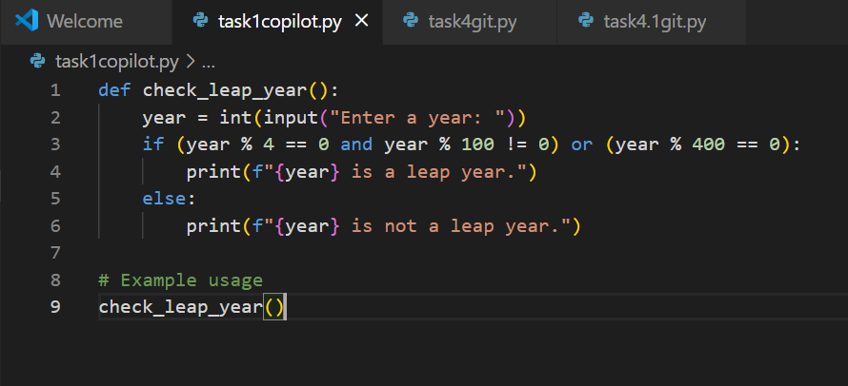

**Output :**

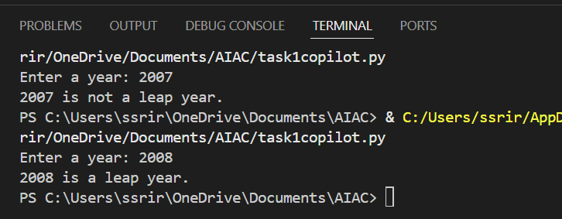

**Cursor AI :**

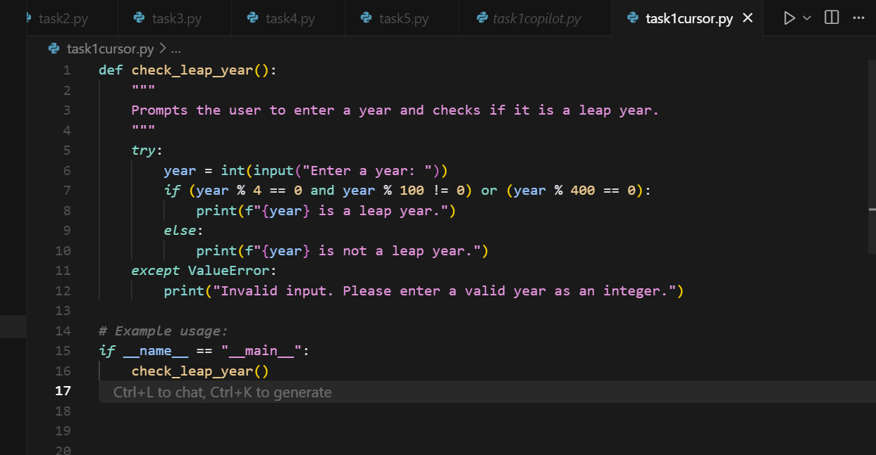

**Output :**

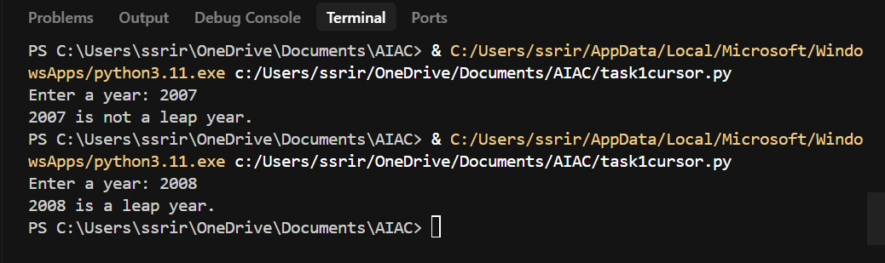

**Task Description#2**● One-shot: Give one input-output example to guide AI in writing a function that  
converts centimeters to inches.  
**Expected Output#2**● Function with correct conversion logic

**Prompt :** write a function that accepts a value from a user converts centimeters to inches. Example : 10 centimeters coverts to 3.93701 inches.

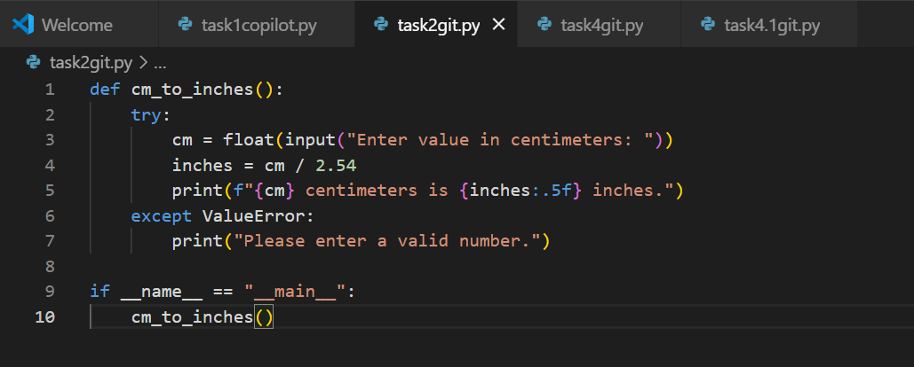

**Output :**

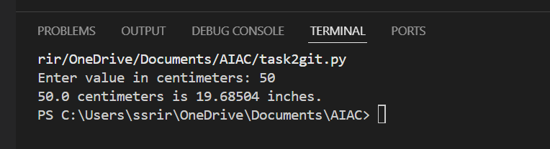

**Cursor AI :**

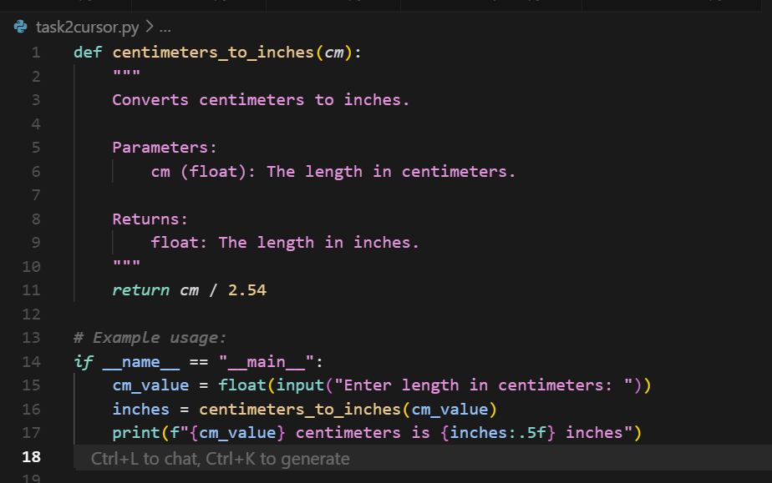

**Output :**

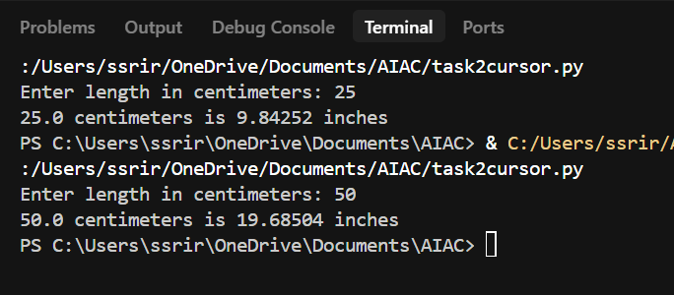

**Task Description#3**  
● Few-shot: Provide 2–3 examples to generate a function that formats full names as  
“Last, First”.  
**Expected Output#3**● Well-structured function respecting the examples.

**Prompt :** Generate a function that formats full names as “Last, First” Examples 1: jhon smith to smith jhon. Example 2 : varsha Reddy to Reddy varsha. Example 3 : asha kumar to kumar asha.

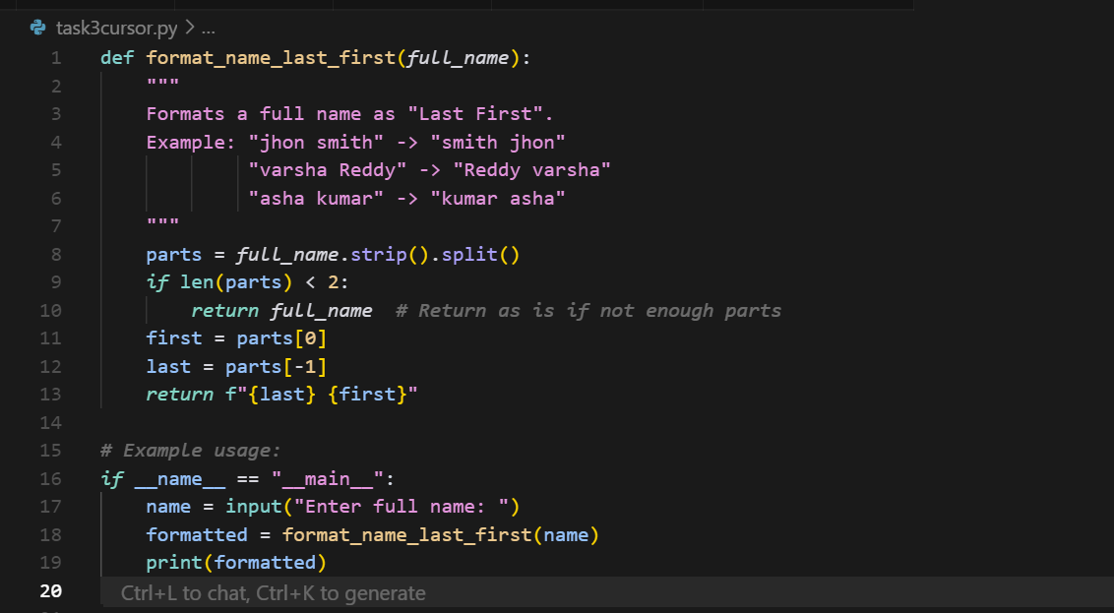

**Output :**

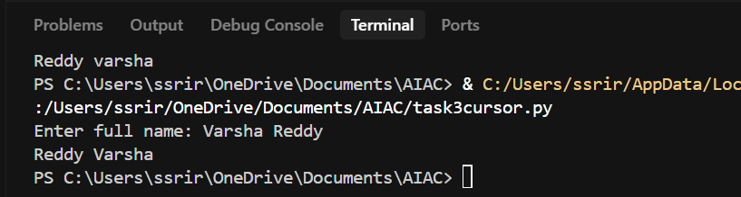

**Prompt :** Generate a function that accepts the string from the user and Convert the string from 'First Last' to 'Last, First' as Examples 1: jhon smith to smith jhon. Example 2 : varsha Reddy to Reddy varsha. Example 3 : asha kumar to kumar asha.

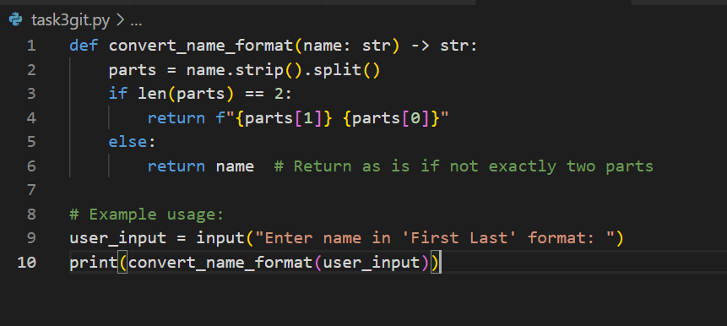

**Output :**

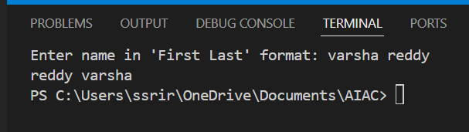

**Task Description#4**  
● Compare zero-shot and few-shot prompts for writing a function that counts the  
number of vowels in a string.  
**Expected Output#4**  
● Functional output and comparative reflection.

**Zero-shot Prompt :** Generate a function that accepts a string from the user and counts the  
number of vowels in a string.

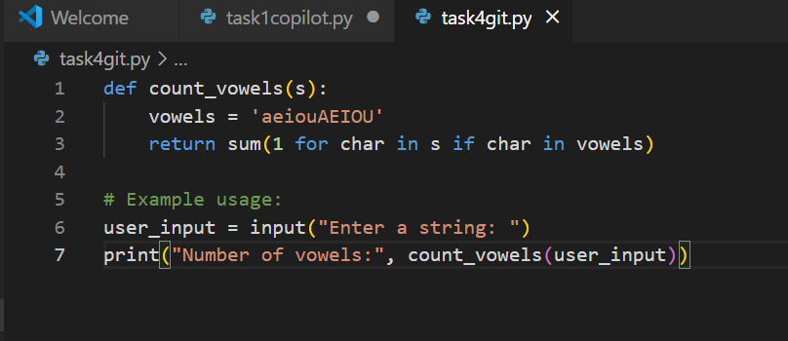

**Output :**

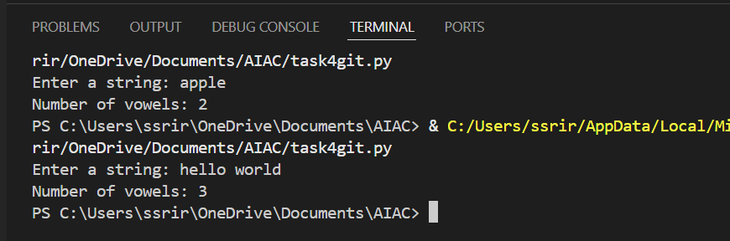

**Cursor AI :**

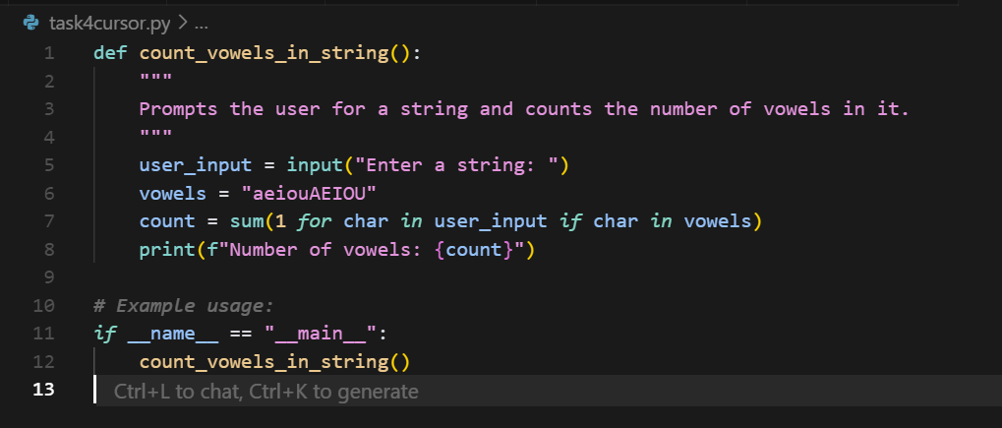

**Output :**

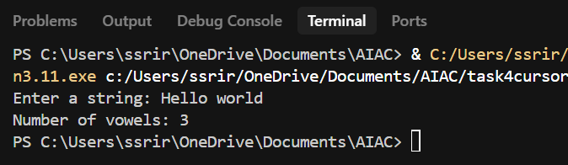

**Few-shot prompt :** Generate a function that accepts a string from the user and counts the number of vowels in a string as

Example 1: Hello world has 3 vowels ,

Example 2: PYTHON programming has 4 vowels ,

Example 3:Rhythm has no vowels

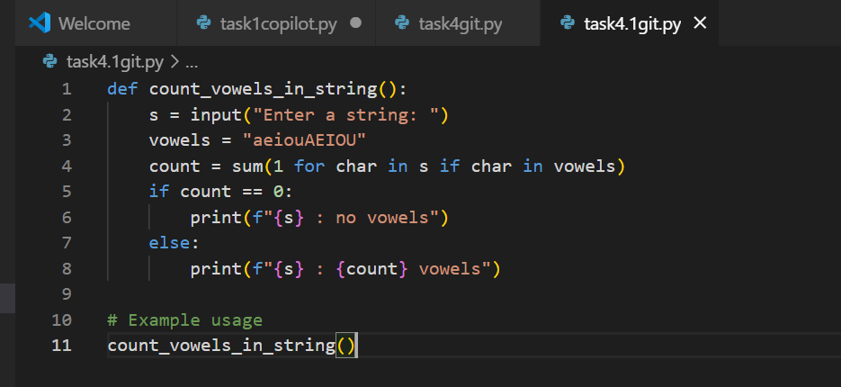

**Output :**

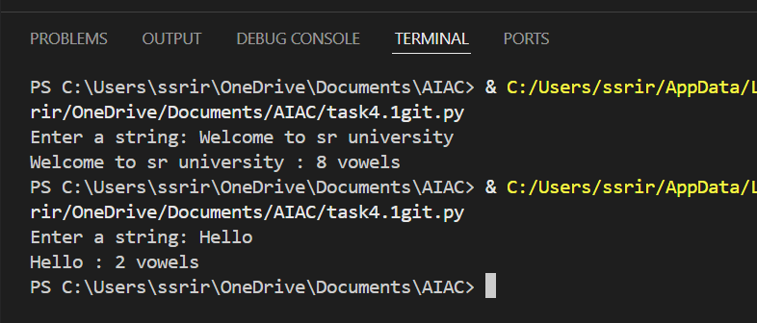

**Cursor AI :**

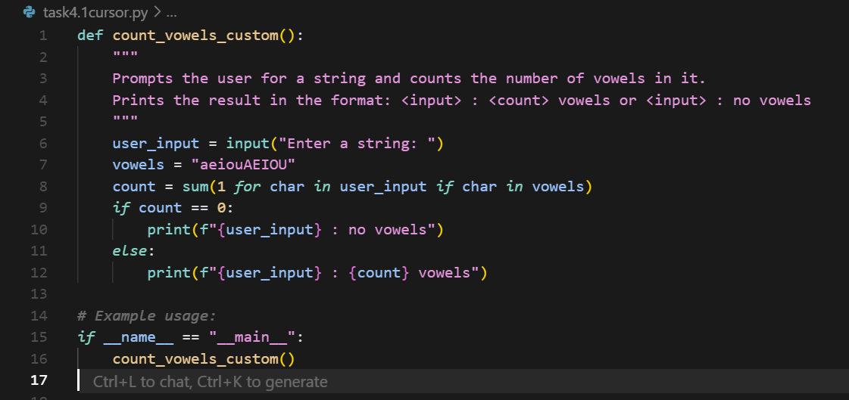

**Output :**

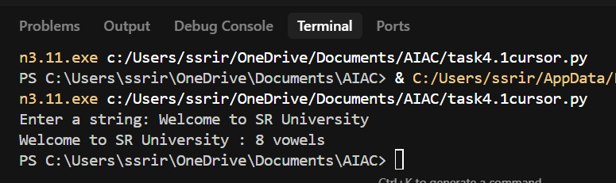

**Task Description#5**● Use few-shot prompting to generate a function that reads a .txt file and returns the  
number of lines.  
**Expected Output#5**● Working file-processing function with AI-guided logic.

**Prompt :** Generate a function that reads a .txt file and returns the number of lines.And display the output. C:\Users\ssrir\OneDrive\Documents\Hello.txt

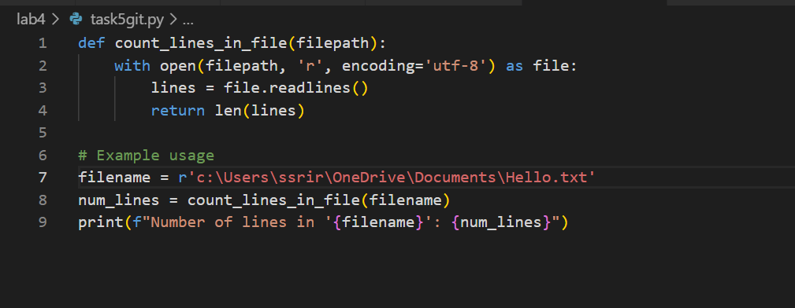

**Output :**

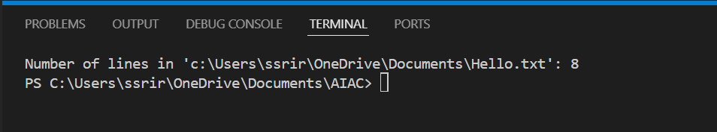

**Cursor AI :**

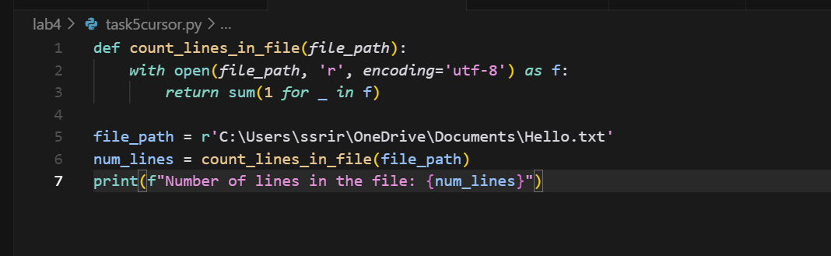

**Output :**

